Graphic Novel Memoir Persepolis: Investigating the context.
EXAMPLE

Instructions: Choose one chapter of the graphic novel Persepolis to investigate further.

Title of the chapter:  The Trip | What are the major ideas in the chapter?  - Education is the tool for socialization and was one of the tools used to socialize young people to the ideas of the new regime.  - We can also see the way in which women were forced to wear the veil, as the “secret police” would threaten them if they did not.  - Lastly, the rationalization of why women had to wear the veil was shown as illogical.
What is the chapter about?

The chapter is about the policies put into effect by the new rulers, and how it drastically changed the lives of the men and women living in Iran.

What is the major historical event is taking place in this chapter? Provide some historical context.  The implementation of the new regime’s policy and how they are using Islam as the reason for all these changes.  One of the major historical event the chapter covers is the American embassy hostage taking in Iran.  As well as the forces that led to the war between Iran and Iraq. | What is Marjane’s experience of the historical event and her point of view?  Marjan’s view of these experiences seems to be entirely personal, for instance, she can no longer go to the USA because of the hostage taking at the embassy.  Also, her confusion about the new regime’s policies shows confusion and a lack of rationality for the new laws and rules, telling us that people in Iran may not have bought into these ideas.
Choose a panel that really stands out for you; cut it out and paste it below. Explain why you connected with it. What storytelling technique is used?  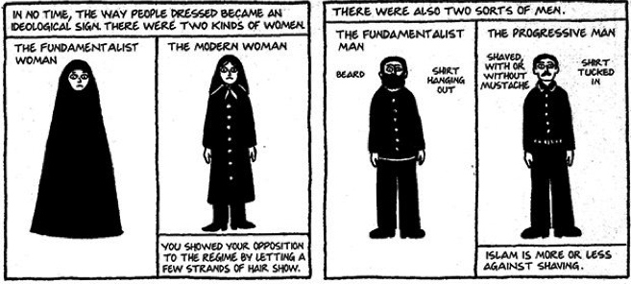  The author attempts to explain the differences between a fundamentalist and modern or progressive person. This stands out for me because at first glance, both women and men look the same, however, upon closer examination we can see there are subtle differences. The author uses subject to subject movement to convey the subtlety between the clothing of both figures. | Choose a storytelling technique (flow, moment, frame, word, or image) and explain whether it is done well or not. How does the panel use storytelling techniques effective?  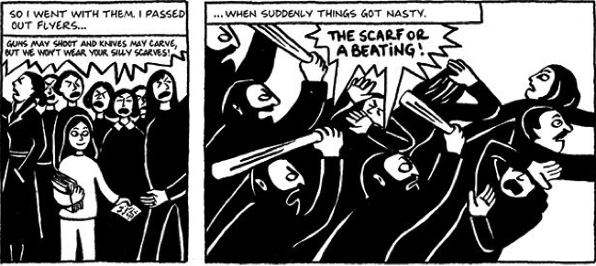  Storytelling technique used is choice of moment. The author shows the dramatic shift of action, with the sudden change in pace of the frames. The panel uses capital letters and bold wording to further emphasis the suddenness of the action in panel two.
Graphic Novel Memoir Persepolis: Investigating the context.

Instructions: Choose one chapter of the graphic novel Persepolis to investigate further.

Title of the chapter: | What are the major ideas in the chapter?
What is the chapter about?

What is the major historical event is taking place in this chapter? Provide some historical context. | What is Marjane’s experience of the historical event and her point of view?
Choose a panel that really stands out for you; cut it out and paste it below. Explain why you connected with it. What storytelling technique is used? | Choose a storytelling technique (flow, moment, frame, word, or image) and explain whether it is done well or not. How does the panel use storytelling techniques effective?

